
Community Interest Company

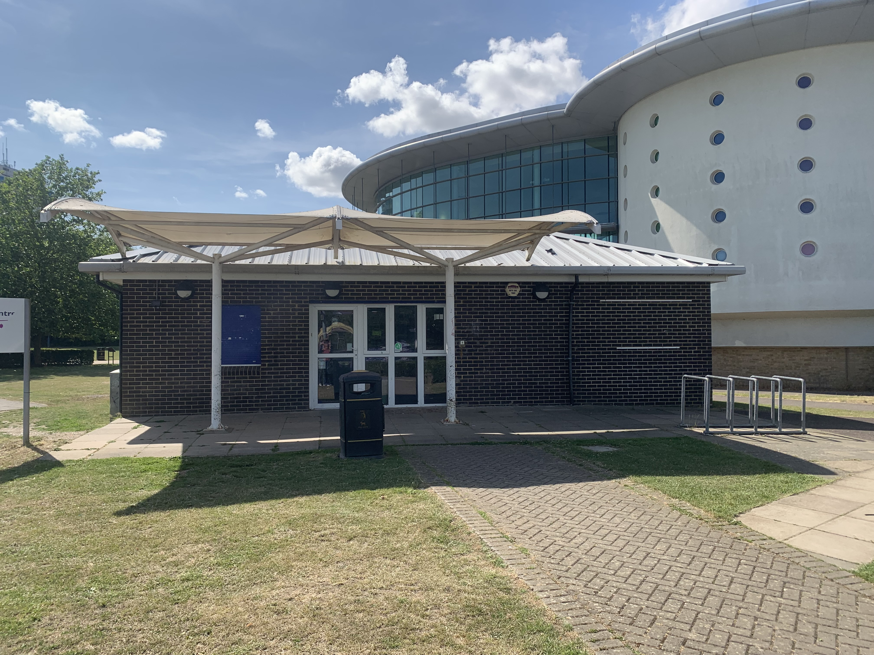

Summer Programme 2024


Week One
Mon 22 July | 1.00-5.00 | Sk8side | Drop-in / Arts Mix
 | 5.00-6.00 | Sk8side | Supper Club
Tue 23 July | 1.00-8.00 | Sk8side | Drop-in / Superteams
 | 5.00-6.00 | Sk8side | Supper Club
 | 6.00-8.00 | Skate Park | Skate Lessons
Thu 25 July | 1.00-5.00 | Sk8side | Drop-in / Baking
 | 4.30-6.00 | Sk8side | Superteams
 | 5.00-6.00 | Sk8side | Supper Club
Fri 26 July | 11.00-3.00 | Chatham | Trip to Ninja Warrior
 | 1.00-5.00 | Sk8side | Drop-in
 | 5.00-6.00 | Sk8side | Supper Club
 | 6.00-7.00 | Sk8side | Skate Fest Planning
Sat 27 July | 2.00-3.00 | Skate Park | Scooter and Roller Skating Lessons
 | 2.00-5.00 | Sk8side | Drop-in & Cake Sale


Signing Up
To become a member of Sk8side just pop in when the centre is open

Week Two
Mon 29 July | 1.00-5.00 | Sk8side | Drop-in / Superteams / Scavenger Hunt Starts/ Still Life Painting
 | 5.00-6.00 | Sk8side | Supper Club
Tue 30 July | 1.00-6.00 | Sk8side | Drop-in / Superteams / Graffiti Art Session
 | 5.00-6.00 | Sk8side | Supper Club
 | 6.00-8.00 | Skate Park | Skate Lessons
Thu 1 Aug | 1.00-5.00 | Sk8side | Drop-in / Clay Modelling
 | 5.00-6.00 | Sk8side | Supper Club
Fri 2 Aug | 2.00-5.00 | Hollywood Bowl | Bowling Trip & Meal
 | 1.00-5.00 | Sk8side | Drop-in
 | 5.00-6.00 | Sk8side | Supper Club
 | 6.00-7.00 | Sk8side | End of Scavenger Hunt
Sat 3 Aug | 2.00-3.00 | Skate Park | Scooter and Roller Skating Lessons
 | 2.00-5.00 | Sk8side | Drop-in

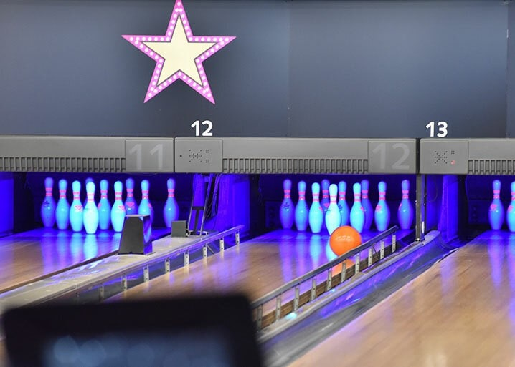
Superteams
Superteams runs throughout the summer holidays. Teams of up to 6 take part in 40 challenges

Week Three
Mon 5 Aug | 1.00-5.00 | Sk8side | Drop-in / Board Games
 | 5.00-6.00 | Sk8side | Supper Club
Tue 6 Aug | 1.00-6.00 | Civic Park | 5-a-side Football Comp
 | 6.00-8.00 | Skate Park | Skate Lessons
Thu 8 Aug | 1.00-5.00 | Sk8side | Drop-in / Circus Skills
 | 5.00-6.00 | Sk8side | Supper Club
Fri 9 Aug | 1.00-5.00 | Flip out | Trip
 | 1.00-5.00 | Sk8side | Drop-in
 | 5.00-6.00 | Sk8side | Supper Club
 | 6.00-7.00 | Sk8side | Skate Fest Planning
Sat 10 Aug | 11.00-5.00 | The Bandstand | Fundraising Day



Bandstand
Join us on Saturday at the bandstand where we will be running some fundraising activities….Challenge Riley….Tombola…..Live Music…..and more…..

Week Four
Mon 12 Aug | 1.00-5.00 | Sk8side | Drop-in / Superteams  Wood Burning Arts
 | 5.00-6.00 | Sk8side | Supper Club
Tue 13 Aug | 1.00-6.00 | Sk8side | Drop-in / Tie-dying
 | 5.00-6.00 | Sk8side | Supper Club
 | 6.00-8.00 | Skate Park | Skate Lessons
Thu 15 Aug | 1.00-6.00 | Sk8side | Drop-in / PS4 FIFA Comp
 | 5.00-6.00 | Sk8side | Supper Club
Fri 16 Aug | 10.00-6.00 | London | Sightseeing
 | 1.00-5.00 | Sk8side | Drop-in
 | 5.00-6.00 | Sk8side | Supper Club
 | 6.00-7.00 | Sk8side | Skate Fest Planning
Sat 17 Aug | 2.00-3.00 | Skate Park | Scooter and Roller Skating Lessons
 | 2.00-5.00 | Sk8side | Drop-in


Free
All our activities are free of charge

Week Five
Mon 19 Aug | 1.00-5.00 | Sk8side | Drop-in / Treasure Hunt
 | 5.00-6.00 | Sk8side | Supper Club
Tue 20 Aug | 1.00-6.00 | Sk8side | Drop-in / Superteams / T-shirt Printing
 | 5.00-6.00 | Sk8side | Supper Club
 | 6.00-8.00 | Skate Park | Skate Lessons
Thu 22 Aug | 1.00-5.00 | Sk8side | Drop-in / Sports Day
 | 5.00-6.00 | Sk8side | Supper Club
Fri 23 Aug | 12.00-4.30 | Folkestone | Sea Fishing
 | 1.00-5.00 | Sk8side | Drop-in
 | 5.00-6.00 | Sk8side | Supper Club
 | 6.00-7.00 | Sk8side | Skate Fest Planning
Sat 24 Aug | 2.00-3.00 | Skate Park | Scooter and Roller Skating Lessons
 | 2.00-5.00 | Sk8side | Drop-in

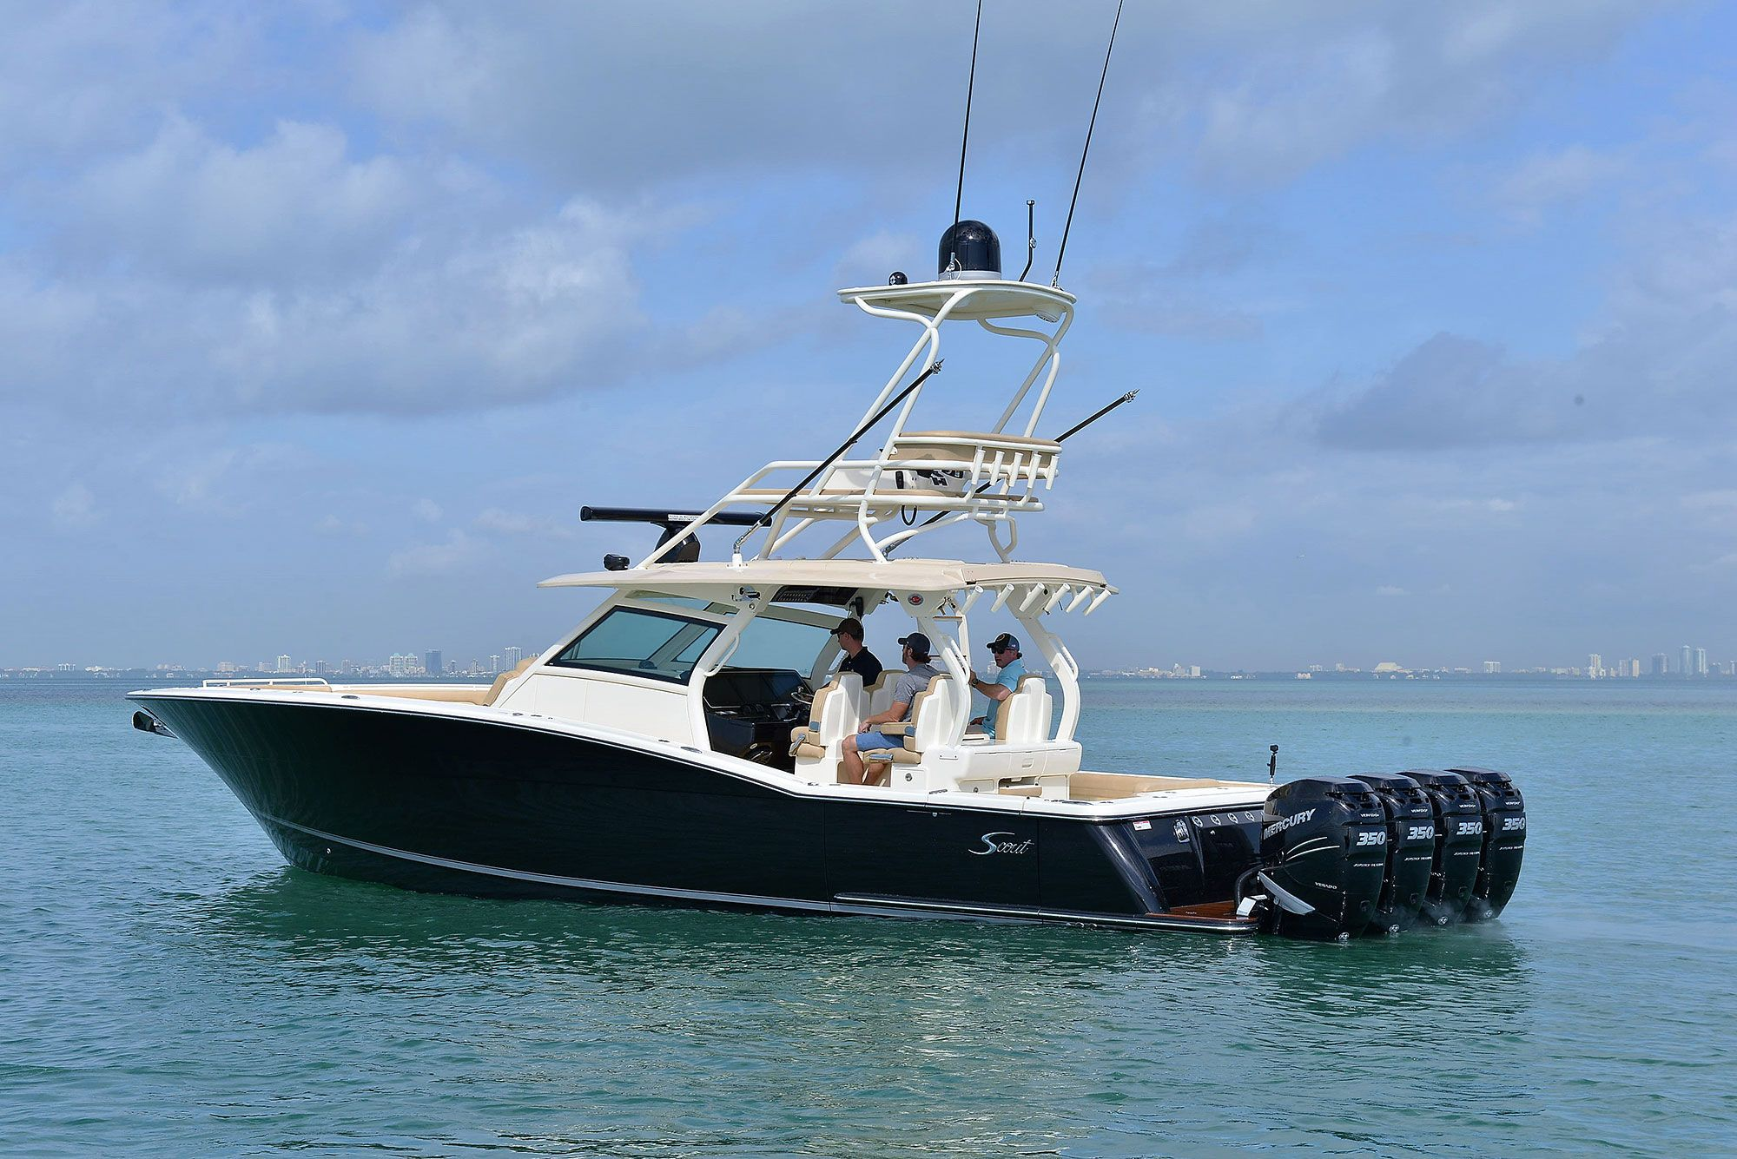
Lessons
Two of our members will be running lessons for beginners in scooter riding and roller skating on Saturdays during the holiday
Week Six
Tue 27 Aug | 1.00-6.00 | Sk8side | Drop-in / DJ Workshop
 | 5.00-6.00 | Sk8side | Supper Club
 | 6.00-8.00 | Skate Park | Skate Lessons
Thu 29 Aug | 1.00-6.00 | Sk8side | Drop-in / Badge Making
 | 4.30-6.00 | Sk8side | Superteams Finale
Fri 30 Aug | Afternoon | Stour Centre | Swimming
 | 1.00-5.00 | Sk8side | Prep for Skate Park Fest
 | 5.00-6.00 | Sk8side | Supper Club
 | 6.00-7.00 | Sk8side | Skate Fest Planning
Sun 1 Sept | 12.00-7.00 | Sk8side / Park | Skate Park Fest

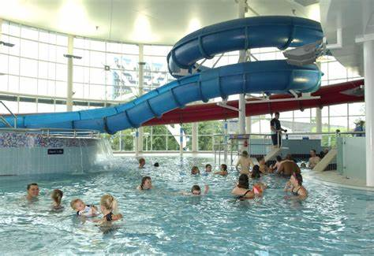
Skate Park Fest
Sunday 1st September……...Competitions in Skateboarding……… Scootering….BMX….Roller Skating….Food…Live Music and stalls

Sk8side Youth Centre, Tannery Lane, Ashford, TN23 1XZ
01233 642156
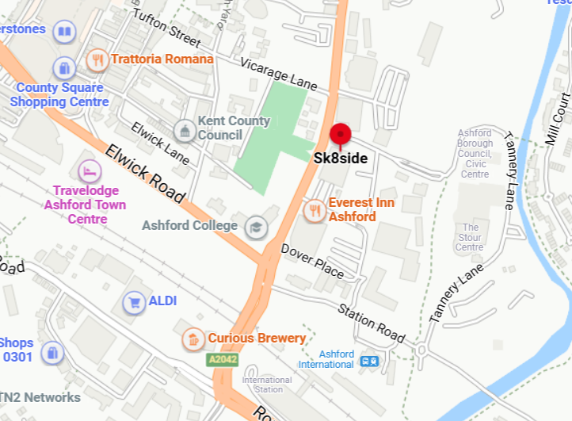
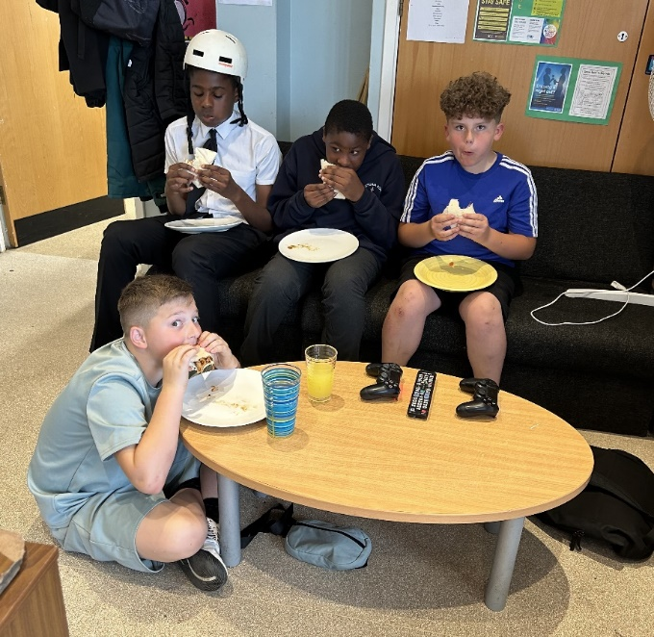
Supper Club…..5.pm!


sk8side ashford I Instagram sk8sidecic

website www.sk8side.co.uk

