THE ASHFORD HUNT

October Half-Term Competition
35 Pictures of Features in Ashford Town Centre
Running Tuesday 27-Thursday 29 October

CAN YOU IDENTIFY THEM?
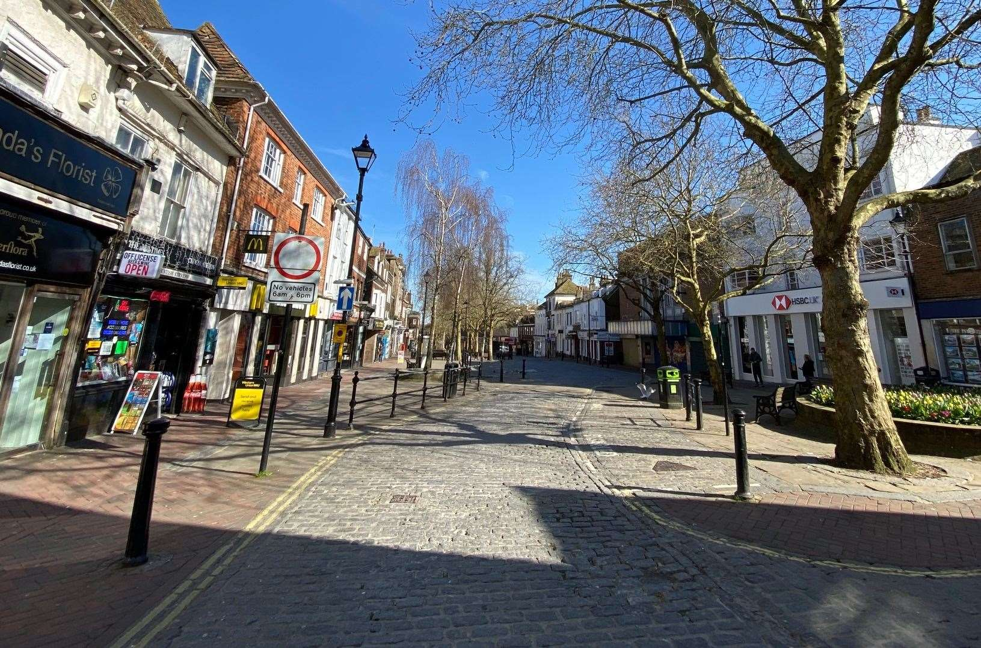
Pick up your copy of pictures from Sk8side
Take your own photos of each feature
A £50 Amazon Voucher for the winner
Here’s a couple to start you off……….

