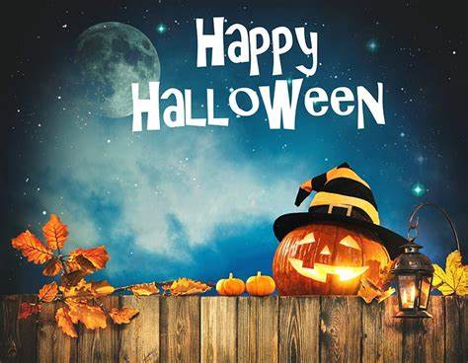

Halloween Party
Friday 30 October
3.00-7.00
On the Patio
Snacks – Music
Prize for the Best Costume

